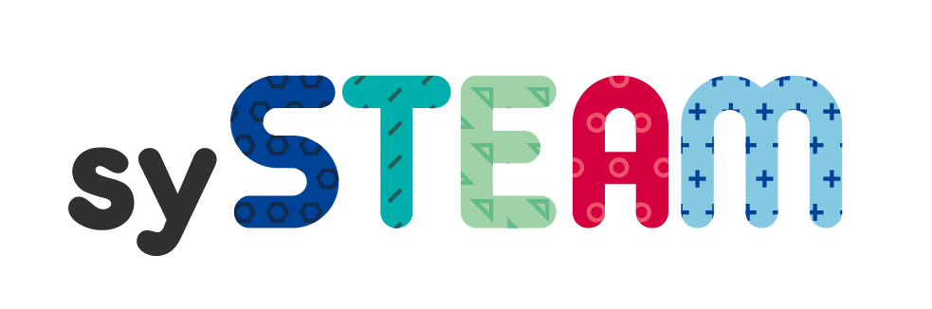
GUIDELINES FOR INTEGRATING DIFFERENT SUBJECTS
Science, Technology, Engineering, Arts and Mathematics)
From Estonia

Look at the three examples below,
Discuss each of the three examples, what do you like, what do you dislike about each one?
How might you include either the cultural or creative competence into these topics?

Option 1: Topic-based (multidisciplinary)

Common topic is chosen. Different subjects address that topic. There are no common tasks in different subjects. Each teacher can do whatever he/she wants and how he/she wants (there should be no restrictions). There can be situation that other teachers do not know exactly what others are doing or how deeply they deal with that theme.
Example: The topic is medieval time, that is thought in 7th grade. During history lessons students learn about medieval European cities. During music lessons students learn about medieval and church music. Medieval literature is the topic of Estonian language classes and during math lessons teacher talks about medieval units of measurement etc.

Option 2: Interdisciplinary

Common topic is chosen. Different subjects address that topic. There are common tasks in different
subjects. Other teachers do know exactly what others are doing or how deeply they deal with that theme.
They plan together learning process and tasks. Not only every subject knowledge-based outcomes are important, but also concepts and skills. Mostly these tasks are not real-life context based (but just task: make poster or map).
Example: In 5th grade science pupils learn food chains. So, in art lesson pupils draw different animals and plants. In science lesson pupils use drawings to make different food chains.
Example: In 6th grade history pupils learn about ancient Greek, in literature lesson pupils read ancient Greek mythology, in art lesson and music they also learn same theme. They have common bigger tasks.

Option 3: Transdisciplinary

Substantive, practical and vital output, generally in the form of project learning. Generally, students work in groups. Important are general competences and the necessary skills for the future work. However, the learning outcomes of different subjects are also acquired.
Example: 9th grade students create within two months a student company, whose products (for example, made of chocolate) are sold to the school community on the Christmas fair. During the fair students have to introduce their products in various foreign languages (for example, Russian, German, English) and in their own language (Estonian). For this they have to design advertisements and write brochures for product promotion or make a video (this is done during mother tongue and foreign language lessons).
During mathematics lesson students learn how to create a budget (including, for example, learning to understand how to calculate labour costs). Work and technology studies in cooperation with art and
computer science classes will help to design and manufacture packages for the product. During art lesson students create logos for their company. In cooking class, they learn how to make chocolate and try different recipes. During chemistry classes they make experiments with chocolate (cocoa). Geography, civic education classes (fair trade, human rights) and English lessons (documentary about child labour) contribute to learning about cocoa route from Africa to Europe and issues related to that. A visiting/quest teacher (entrepreneur) will introduce his profession to the pupils. In addition, there are lessons directly linked to creation of a student company (for example team building, target group selection, product related polls, product selection, company name selection, summarizing and feedback etc.)

